How to Install Nginx on FreeBSD 11.2
NginxFreeBSD

- By Mark Drake
Published onNovember 15, 2018 30.6k views

Not using FreeBSD 11?
Choose a different version or distribution.

Introduction
Nginx is one of the most popular web servers in the world, known for its frequent use as a load balancer and reverse proxy. It’s more resource-friendly than Apache, and many of the largest and most highly trafficked sites on the internet depend on Nginx to serve their content.
In this guide, we will demonstrate how to install Nginx on a FreeBSD 11.2 server.

Prerequisites
Before beginning this guide, you will need access to a server running FreeBSD. This guide was written specifically with a server running FreeBSD 11.2 in mind, although it should also work on older, supported versions of the operating system.
If you’re new to working with FreeBSD, you may find it helpful to customize this server by following these instructions.
Additionally, if you plan to set up a domain name for this server, you will need the following:
- A registered domain name that you own and control. If you do not already have a registered domain name, you may register one with one of the many domain name registrars out there (e.g. Namecheap, GoDaddy, etc.).
- A DNS A Record that points your domain to the public IP address of your server. You can follow this hostname tutorial for details on how to add them.

Step 1 — Installing Nginx
To begin, we will install Nginx using pkg, FreeBSD’s built-in binary package management tool. The following command will update your local copy of the available packages and then install the nginx package:
sudo pkg install nginx

If this is your first time running pkg, it will prompt you to confirm that you allow it to bootstrap itself. To do this, press y and then ENTER. Then, when prompted, confirm that you approve the installation of the nginx package by pressing y and then ENTER once again.
If you are using either the csh or tcsh shell, make sure to run the rehash command. This makes the shell aware of the new applications you installed:
rehash

Note: If you aren’t sure which shell you’re currently using, you can check with the following command:
echo $SHELL

The output will show the file path of the shell program currently in use:
Output
/bin/tcsh
Nginx is now installed on your server, but it is not yet running. In the next step, we’ll enable Nginx to start running every time the server boots up and start it for this session, as well as walk through the process of securing the server by setting up a firewall with IPFW.

Step 2 — Enabling the Nginx Service and Setting Up a Firewall with IPFW
In order for FreeBSD to start Nginx as a conventional service, you have to tell FreeBSD that you want to enable it. This will allow you to manage it like any other service, rather than as a standalone application, and will also configure FreeBSD to start it up automatically at boot.
To do this, you first need to know the correct rc parameter to set for the nginx service. rc is a FreeBSD utility that controls the system’s automatic boot processes. Scripts for every service available on the system are located in the /usr/local/etc/rc.d directory. These define the parameters that are used to enable each service using the rcvar variable. We can see what each service’s rcvar is set to by typing:
grep rcvar /usr/local/etc/rc.d/*

After has been installed, this command will output a listing similar to this:
Output
/usr/local/etc/rc.d/cloudconfig:rcvar="cloudinit_enable"
/usr/local/etc/rc.d/cloudfinal:rcvar="cloudinit_enable"
/usr/local/etc/rc.d/cloudinit:rcvar="cloudinit_enable"
/usr/local/etc/rc.d/cloudinitlocal:rcvar="cloudinit_enable"
/usr/local/etc/rc.d/nginx:rcvar=nginx_enable
/usr/local/etc/rc.d/rsyncd:rcvar=rsyncd_enable
The parameter that you need to set for the nginx service is highlighted here in this output. The name of the script itself — the last component of the path before the colon — is also helpful to know, as that’s the name that FreeBSD uses to refer to the service.
To enable the nginx service you must add its rcvar to the rc.conf file, which holds the global system configuration information referenced by the startup scripts. Use your preferred editor to open the /etc/rc.conf file with sudo privileges. Here, we’ll use ee:
sudo ee /etc/rc.conf

At the top of the file, there will be a few rcvar parameters already in place. Add the nginx_enable rcvar parameter below these and set it to "YES":
/etc/rc.conf
. . .
sshd_enable="YES"
nginx_enable="YES"

. . .

While still in the rc.conf file, we will add a few more directives to enable and configure an IPFW firewall. IPFW is a stateful firewall written for FreeBSD. It provides a powerful syntax that allows you to customize security rules for most use cases.
Directly below the nginx_enable parameter you just added, add the following highlighted lines:
/etc/rc.conf
. . .
nginx_enable="YES"
firewall_enable="YES"
firewall_type="workstation"
firewall_myservices="22/tcp 80/tcp"
firewall_allowservices="any"

Here’s what each of these directives and their settings do:
- firewall_enable="YES" — Setting this directive to "YES" enables the firewall to start up whenever the server boots.
- firewall_type="workstation" — FreeBSD provides several default types of firewalls, each of which have slightly different configurations. By declaring the workstation type, the firewall will only protect this server using stateful rules.
- firewall_myservices="22/tcp 80/tcp" — The firewall_myservices directive is where you can list the TCP ports you want to allow through the firewall. In this example, we’re specifying ports 22 and 80 to allow SSH and HTTP access to the server, respectively.
- firewall_allowservices="any" — This allows a machine from any IP address to communicate over the ports specified in the firewall_myservices directive.
After adding these lines, save the file and close the editor by pressing CTRL + C, typing exit, and then pressing ENTER.
Then, start the ipfw firewall service. Because this is the first time you’re starting the firewall on this server, there’s a chance that doing so will cause your server to stall, making it inaccessible over SSH. The following nohup command — which stands for “no hangups” — will start the firewall while preventing stalling and also redirect the standard output and error to a temporary log file:
sudo nohup service ipfw start >/tmp/ipfw.log 2>&1

If you’re using either the csh or tcsh shells, though, this redirect will cause Ambiguous output redirect. to appear in your output. If you’re using either of these shells, run the following instead to start ipfw:
sudo nohup service ipfw start >&/tmp/ipfw.log

Note: In the future, you can manage the ipfw firewall as you would any other service. For example, to stop, start, and then restart the service, you would run the following commands:
sudo service ipfw stop
sudo service ipfw start
sudo service ipfw restart

Next, start the nginx service
sudo service nginx start

Then, to test that Nginx is able to serve content correctly, enter your server’s public IP address into the URL bar of your preferred web browser:
http://your_server_ip
Note: If you aren’t sure of your server’s public IP address, you can run the following command which will print your server’s IP address, as seen from another location on the internet:
curl -4 icanhazip.com

If everything is working correctly, you will see the default Nginx landing page:
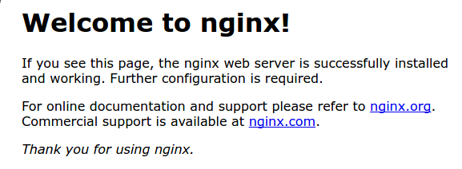
This shows that Nginx is installed and running correctly and that it’s being allowed through the firewall as expected. There are still a few configuration changes that need to be made, though, in order for it to work with non-default settings or serve content using a domain name.

Step 3 — Setting Up a Server Block
When using the Nginx web server, server blocks (similar to virtual hosts in Apache) can be used to encapsulate configuration details and host more than one domain from a single server. We will set up a domain called example.com, but you should replace this with your own domain name. To learn more about setting up a domain name with DigitalOcean, see our Introduction to DigitalOcean DNS.
Nginx on FreeBSD 11.2 has one server block enabled by default that is configured to serve documents out of a directory at /usr/local/www/nginx. While this works well for a single site, it can become unwieldy if you are hosting multiple sites. Instead of modifying /usr/local/www/nginx, let’s create a directory structure within /usr/local/www for our example.com site.
Create the directory for example.com as follows, using the -p flag to create any necessary parent directories:
sudo mkdir -p /usr/local/www/example.com/html

Next, assign ownership of the directory to the www user, the default Nginx runtime user profile:
sudo chown -R www:www /usr/local/www/example.com

The permissions of your web root should be correct if you haven’t modified your umask value, but you can make sure by typing:
sudo chmod -R 755 /usr/local/www/example.com

Next, create a sample index.html page using ee:
sudo ee /usr/local/www/example.com/html/index.html

Inside, add the following sample HTML:
/usr/local/www/example.com/html/index.html
<html>
<head>
<title>Welcome to Example.com!</title>
</head>
<body>
<h1>Success! The example.com server block is working!</h1>
</body>
</html>

Save and close the file when you are finished.
In order for Nginx to serve this content, it’s necessary to create a server block with the correct directives. Open the main Nginx configuration file. By default, this is held in the /usr/local/etc/nginx/ directory:
sudo ee /usr/local/etc/nginx/nginx.conf

Note: Generally, you want to avoid editing the default nginx.conf file. However, within this same directory, there’s a file called nginx.conf-dist, which is identical to the default nginx.conf file. If you ever find that you need to revert with these configuration changes, you can just copy over this file with the following command:
sudo cp /usr/local/etc/nginx/nginx.conf-dist /usr/local/etc/nginx/nginx.conf

When you first open the file, you’ll see the following at the very top:
/usr/local/etc/nginx/nginx.conf
#user nobody;
worker_processes 1;

. . .

Uncomment the user directive by removing the pound sign (#) and then change the user from nobody to www. Then update the worker_processes directive which allows you to select how many worker processes Nginx will use. The optimal value to enter here isn’t always obvious or easy to find. Setting it to auto tells Nginx sets it to one worker per CPU core, which will be sufficient in most cases:
/usr/local/etc/nginx/nginx.conf
user www;
worker_processes auto;
. . .

Then scroll down to the server block. With all comments removed, it will look like this:
/usr/local/etc/nginx/nginx.conf
. . .
server {
listen 80;
server_name localhost;

location / {
root /usr/local/www/nginx;
index index.html index.htm;
}

error_page 500 502 503 504 /50x.html;

location = /50x.html {
root /usr/local/www/nginx-dist;
}
}

Delete this entire server block, including all the commented-out lines, and replace it with the following content:
/usr/local/etc/nginx/nginx.conf
. . .
server {
access_log /var/log/nginx/example.com.access.log;
error_log /var/log/nginx/example.com.error.log;
listen 80;
server_name example.com www.example.com;

location / {
root /usr/local/www/example.com/html;
index index.html index.htm;
}
}
. . .

Here’s what the directives in this server block do:
- access_log: This directive defines the location of the server’s access logs.
- error_log: This defines the file where Nginx will write its error logs.
- listen: The listen directive declares what port Nginx should listen in on. In this case, we set it to port 80 so it can listen for HTTP traffic.
- server_name: Here, point Nginx to your domain name and any aliases you have for it. If you don’t have a domain name, point Nginx to your server’s public IP address.
- root: This defines the website document root, which you created earlier in this step.
- index: This directive defines the files that will be used as an index, and in which order they should be checked.
All together, with comments removed, the file will look like this:
/usr/local/letc/nginx/nginx.conf
user www;
worker_processes 1;

events {
worker_connections 1024;
}

http {
include mime.types;
default_type application/octet-stream;
sendfile on;
keepalive_timeout 65;

server {
access_log /var/log/nginx/example.com.access.log;
error_log /var/log/nginx/example.com.error.log;
listen 80;
server_name example.com www.example.com;

location / {
root /usr/local/www/example.com;
index index.html index.htm;
}

}

}

Save and close the file when you are finished. Then, test your configuration file for syntax errors by typing:
sudo nginx -t

If your configuration file has no detectable syntax errors, you’ll see the following output:
Output
nginx: the configuration file /usr/local/etc/nginx/nginx.conf syntax is ok
nginx: configuration file /usr/local/etc/nginx/nginx.conf test is successful
If the above command returns with errors, re-open the Nginx configuration file to the location where the error was found and try to fix the problem.
When your configuration checks out correctly, go ahead and reload the nginx service to enable your changes:
sudo service nginx reload

Nginx should now be serving the content you set up in the index.html file. Test this by navigating to http://example.com, where you should see something like this:
As a final step, we will go over some commands that will allow you to manage the Nginx service.

Step 4 — Managing the Nginx Process
Now that you have your web server up and running, let’s review some basic management commands.
To stop your web server, type:
sudo service nginx stop

To start the web server when it is stopped, type:
sudo service nginx start

To stop and then start the service again, type:
sudo service nginx restart

If you are simply making configuration changes, you can reload Nginx without dropping any connections. To do this, type:
sudo service nginx reload

Lastly, recall how in Step 2 we enabled the nginx service by adding the nginx_enable="YES" directive to the rc.conf file. If you’d like to disable the nginx service to keep it from starting up when the server boots, you would need to reopen that file and remove that line.

Conclusion
You now have a fully functional Nginx web server installed on your machine. From here, you could encrypt your server’s web traffic by enabling HTTPS. To learn how to do this, consult How To Secure Nginx with Let’s Encrypt on FreeBSD. You could also install and configure MySQL and PHP which, along with Nginx, would give you a complete FEMP stack.
https://www.digitalocean.com/community/tutorials/how-to-install-nginx-freebsd-11-2

FreeBSD Install Nginx Webserver Tutorial
Author: Vivek Gite Last updated: September 24, 2018 4 comments

How do I install an Nginx webserver under a FreeBSD Unix operating system? How can I install Nginx web server on FreeBSD?
nginx [engine x] is a HTTP server, reverse proxy and mail proxy server written by Igor Sysoev. It is a lightweight web server, licensed under a BSD-like license. It the fastest growing and one of the most popular web server. This page shows how to install Nginx webserver on FreeBSD based server.

FreeBSD Install Nginx Webserver
The procedure for installing Nginx on FreeBSD is as follows:
- Install nginx using pkg command: pkg install nginx
- Turn on Nginx service on FreeBSD: sysrc nginx_enable=YES
- Configure Nginx server by editing /usr/local/etc/nginx/nginx.conf file
- Test the setup
Let us see all steps in details.

Update FreeBSD ports tree
Type the following command to update FreeBSD tree, enter:
# portsnap fetch update
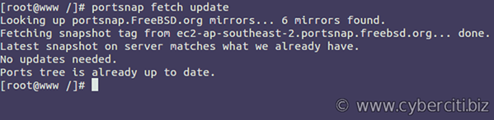

Installing Nginx using FreeBSD ports
Run the following command to install the Nginx web server port:
# cd /usr/ports/www/nginx/
# make install clean
Make sure you select important option such as REWRITE_MODULE, SSL_MODULE and others as per your requirements.

Installing nginx using the pkg command
Add the binary package using the following pkg command:
# pkg install nginx
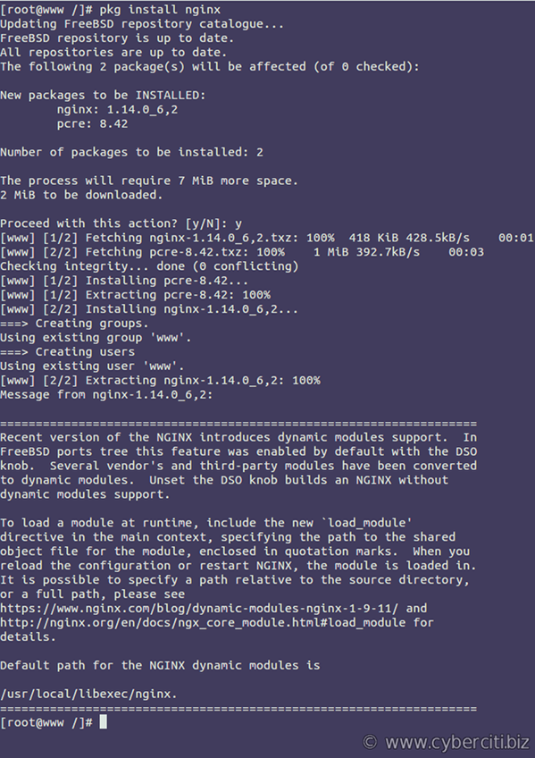

Turn on Nginx Webserver Service
Execute the following command to turn on Nginx server
# echo 'nginx_enable="YES"' >> /etc/rc.conf
OR
# sysrc nginx_enable="YES"
nginx_enable: -> YES

How do I start an nginx server?
To start Nginx, enter:
# /usr/local/etc/rc.d/nginx start
OR
# service nginx start
Sample outputs:
Performing sanity check on nginx configuration:
nginx: the configuration file /usr/local/etc/nginx/nginx.conf syntax is ok
nginx: configuration file /usr/local/etc/nginx/nginx.conf test is successful
Starting nginx.

How do I stop an nginx server?
# /usr/local/etc/rc.d/nginx stop
OR
# service nginx stop

How do I restart an nginx server?
# /usr/local/etc/rc.d/nginx restart
OR
# service nginx restart

How do I reload an nginx server after config file changes?
# /usr/local/etc/rc.d/nginx reload
OR
# service nginx reload

Important Information about Nginx webserver on a FreeBSD
- Nginx Default configuration file: /usr/local/etc/nginx/nginx.conf
- Nginx Default http / https port: 80 / 443
- Nginx Default error log file: /var/log/nginx-error.log
- Nginx Default access log file: /var/log/nginx-access.log
- Nginx Default DocumentRoot: /usr/local/www/nginx/
- Nginx service command: service nginx (start|stop|restart|reload|configtest|upgrade|gracefulstop|status|poll)

Testing the setup
Fire the web browser and type the following url in your web-browser:
http://server-ip-here/
OR your domain name:
http://nixcraft.com/
Sample outputs:

Nginx in action

Creating your first web site
In this example, I am going to install mediawiki software for personal use at /wwwwiki/. Let us create a directory using the mkdir command:
# mkdir /wwwwiki
Create a FreeBSD user for your domain using the pw command:
# pw user add -n wwwwiki -c 'My wiki user' -d /nonexistent -s /usr/sbin/nologin
Lock FreeBSD user named wwwwiki:
# pw lock wwwwiki
Create a sample file for testing purpose:
# vi /wwwwiki/index.html
Append following HTML:
<html>
<head>
<title>Vivek's personal wiki directory</title>
</head>
<body>
<h1>Wiki directory</h1>
<p>This is a test and I will configure PHP 7.x to host mediawiki</p>
<hr>
&copy; <a href="https://www.cyberciti.biz">www.cyberciti.biz</a>
</body>
</html>
Setup directory user and group ownership using the chown command and chmod command:
# chown -R wwwwiki:wwwwiki /wwwwiki/
# chmod -R 0555 /wwwwiki/
# ls -ld /wwwwiki/
Sample outputs:
dr-xr-xr-x 2 wwwwiki wwwwiki 2 Sep 23 23:41 /wwwwiki/

Configure Nginx for wiki virtual domain or IP address
VirtualHost is an Apache server term. Nginx does not have concept of Virtual hosts, it has concept of “Server Blocks” that use the server_name for domains or IP address. Create a config file as follows:
# mkdir /usr/local/etc/nginx/vdomains/
# vi /usr/local/etc/nginx/vdomains/http.192.168.2.31.conf
Append the following config:
server {
server_name 192.168.2.31; # virtual IP or domain name here
access_log /var/log/nginx/192.168.2.31.access.log; # log files
error_log /var/log/nginx/192.168.2.31.error.log;
root /wwwwiki; # root dir for this virtual host
## add more config below such as PHP and so on ##
}
Save and close the file. Update nginx.conf:
# vi /usr/local/etc/nginx/nginx.conf
Add the following just before final }:
include "vdomains/*.conf";
Save and close the file. Verify nginx config and reload it:
# nginx -t
# service nginx reload
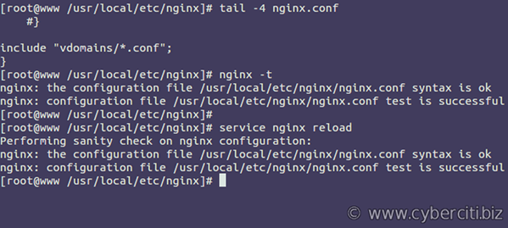
Test the config:
http://192.168.2.31/
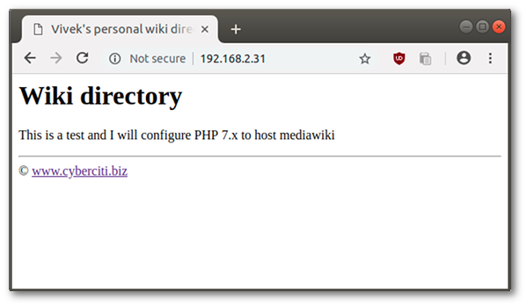

Conclusion
Congratulations. Now you have a fully functional web server powered by Nginx that serve static files. Stay tuned for PHP and MariaDB/MySQL server configuration.
https://www.cyberciti.biz/faq/freebsd-install-nginx-webserver/

FreeBSD install PHP 7.2 with FPM for Nginx
Author: Vivek Gite Last updated: January 14, 2021 2 comments
How do I install install PHP 7.2 with FPM for Nginx web server running on FreeBSD operating system?
Introduction: PHP is an acronym for “PHP: Hypertext Preprocessor.” It is an open source general-purpose scripting language. PHP is handy for web development and to run popular software such as MediaWiki, WordPress, and more. PHP is easy to learn and allows you to write dynamically generated web pages on the fly. This page shows how to install PHP 7.2 on a FreeBSD v11.x Unix box along with Nginx web server.

FreeBSD install PHP 7.2 with FPM for Nginx
The procedure for installing PHP 7.2 on FreeBSD is as follows:
- Update FreeBSD ports tree
- Install PHP 7.2 binary package: pkg install nginx
- Install Nginx binary package
- Configure Nginx and PHP 7.2
- Turn on PHP-fpm service on FreeBSD
- Test the setup
Let us see all steps in details.

1. Update FreeBSD ports tree
You must use the portsnap command # portsnap fetch update
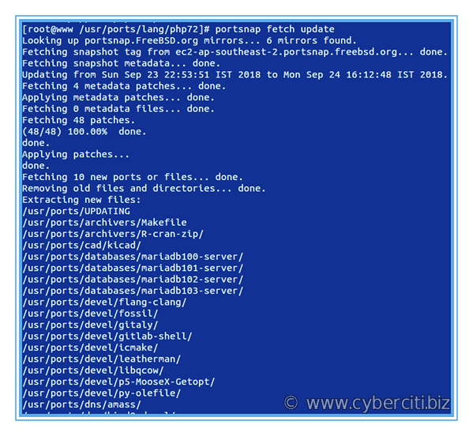

2. Install PHP 7.2 on FreeBSD
You can install PHP 7.2 using ports or binary package method. Use any one of the following methods.

The ports method
# cd /usr/ports/lang/php72/
# make install clean

The binary package method
Run the pkg command to install it:
# pkg install php72
For verification purposes, check PHP version, type:
php -v
php --version

3. Install PHP 7.2 extensions on FreeBSD
Again PHP extensions can be installed using the ports or pkg method. Use any one of the following ways.
To install the port, run the following command and choose required extensions:
# cd /usr/ports/lang/php72-extensions/ && make install clean
OR add the binary package:
# pkg install php72-extensions
Another option is installing individual PHP extensions as per your web application or software project needs. One can search PHP 7.2 extensions using the pkg command and grep command/egrep command # pkg search php72 | grep gd
# pkg search php72 | egrep -i --color 'gd|mysqli|openssl'
# pkg search php72 | egrep --color -i -- '-(gd|mysqli|openssl|memcached|opcache|json|mbstring|imagick|xml|zip|composer|igbinary)-'
Simply install it:
# pkg install php72-composer php72-gd php72-json
### OR ###
# pkg install php72-composer-1.6.5 php72-gd-7.2.10 php72-json-7.2.10 php72-mbstring-7.2.10 php72-mysqli-7.2.10 php72-opcache-7.2.10 php72-openssl-7.2.10 php72-pecl-imagick-3.4.3_2 php72-pecl-memcached-3.0.4 php72-xml-7.2.10 php72-zip-7.2.10 php72-pecl-igbinary-2.0.7

4. Configure PHP-FPM
Edit the file /usr/local/etc/php-fpm.d/www.conf
# vi /usr/local/etc/php-fpm.d/www.conf
Find line:
listen = 127.0.0.1:9000
Update it as follows:
listen = /var/run/php72-fpm.sock
Uncomment the following line:
listen.owner = www
listen.group = www
listen.mode = 0660
Save and close the file. Enable php-fpm service:
# sysrc php_fpm_enable=YES
Commands to start, stop, restart php-fpm service on FreeBSD server:
# service php-fpm stop
# service php-fpm start
# service php-fpm restart
# service php-fpm status

A note about PHP 7 config
You need to install php.ini file using the php command:
# cp -v /usr/local/etc/php.ini-production /usr/local/etc/php.ini
/usr/local/etc/php.ini-production -> /usr/local/etc/php.ini
Next, we are going to secure PHP and customize it:
# vi /usr/local/etc/php/99-custom.ini
Add the following config:
display_errors=Off
safe_mode=Off
safe_mode_exec_dir=
safe_mode_allowed_env_vars=PHP_
expose_php=Off
log_errors=On
error_log=/var/log/nginx/php.scripts.log
register_globals=Off
cgi.force_redirect=0
file_uploads=On
allow_url_fopen=Off
sql.safe_mode=Off
disable_functions=show_source, system, shell_exec, passthru, proc_open, proc_nice, exec
max_execution_time=60
memory_limit=60M
upload_max_filesize=2M
post_max_size=2M
cgi.fix_pathinfo=0
sendmail_path=/usr/sbin/sendmail -fwebmaster@cyberciti.biz -t
Save and close the file. Restart the PHP on FreeBSD:
# service php-fpm restart

5. Configure Nginx to use PHP 7.2 (PHP-FPM)
The final step is connecting Nginx to PHP-FPM service via the FCGI protocol. Edit your Virtual Domain or nginx.conf file as follows:
# cd /usr/local/etc/nginx
# vi nginx.conf
OR
# vi vdomains/http.192.168.2.31.conf
Here is an updated sample config file:
server {
server_name 192.168.2.31; # use domain name if you have here
access_log /var/log/nginx/192.168.2.31.access.log;
error_log /var/log/nginx/192.168.2.31.error.log;

root /wwwwiki;
# php config let nginx talk to php socket
location ~ [^/]\.php(/|$) {
fastcgi_split_path_info ^(.+?\.php)(/.*)$;
if (!-f $document_root$fastcgi_script_name) {
return 404;
}

# Mitigate https://httpoxy.org/ vulnerabilities
fastcgi_param HTTP_PROXY "";

fastcgi_pass unix:/var/run/php72-fpm.sock;
fastcgi_index index.php;

# include the fastcgi_param setting
include fastcgi_params;

# SCRIPT_FILENAME parameter is used for PHP FPM determining
# the script name.
fastcgi_param SCRIPT_FILENAME $document_root$fastcgi_script_name;
}
}
Reload or restart the Nginx server:
# service nginx reload

6. Test the setup
Create a PHP script called test.php in /wwwwiki/
# vi /wwwwiki/test.php
Append the following code that shows information about PHP’s configuration using phpinfo:
<?php
phpinfo();
?>
Save and close the file. Set tight file permissions on DocumentRoot (web server root):
# chown -R wwwwiki:wwwwiki /wwwwiki/
# chmod -R 0555 /wwwwiki/
Fire a web browser and test it:
http://192.168.2.31/test.php
http://your-domain-name-here/test.php
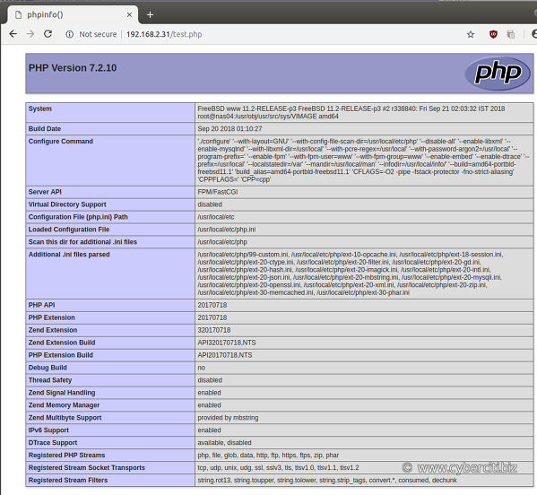
And there you have PHP working as expected and Nginx is talking to PHP-FPM via Unix socket.

How to verify that PHP-fpm running
Use the sockstat command on FreeBSD to list running services, open ports and unix sockets:
# sockstat -46lu | egrep --color 'www|nginx|php'
Also check log files if you get any problems running PHP:
# ls -l /var/log/nginx/
# tail -f /var/log/nginx/192.168.2.31.error.log
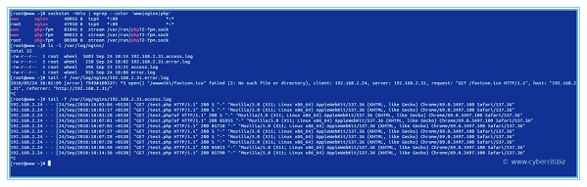
Click to enlarge image

Conclusion
This guide demonstrated how to install PHP FPM securely and configured it using unix socket. Now you have fully working Nginx server along with PHP 7.2 for creating dynamic web pages on demand. Next part of the series shows how to install a database server to build a fully functional web server running on a FreeBSD operating system.

Install MariaDB Databases on a FreeBSD 11 Unix Server
Author: Wendy Michele Last updated: September 25, 2018 2 comments
I‘m a new FreeBSD unix user. How can I install MariaDB database server on a FreeBSD unix based system?
MySQL is a high-speed, multi-threaded, multi-user and robust SQL database server. MariaDB is a database server that offers drop-in replacement functionality
for Oracle MySQL server. MariaDB is built by some of the original authors of MySQL, with assistance from the community. This page shows how to install MariaDB Databases on a FreeBSD 10/11 Unix Server.

How To Install MariaDB Databases on a FreeBSD
The procedure to install MariaDB server is as follows:
- Find MariaDB server package names.
- Install MariaDB server either using the ports or pkg command.
- Start MariaDB server
- Set root password for MariaDB server
- Create a database, user, and grant rights
- Open MariaDB ports using the firewall

Update all your ports
Make sure your ports are installed and up to date. I like to do:
# portsnap fetch update && portupgrade -a

FreeBSD MariaDB installation
To install MariaDB Server, MariaDB Client and MariaDB Scripts type the following commands.

A note about MySQL and MariaDB server together
You cannot run MariaDB and MySQL installed together. You will have deinstall one or the other and the clients if you have them. If you want to run them both, you
will need them to be jailed apart. If you are new it’s best to not think about this and run them one at a time focusing on learning one or the other. So for example if you have MySQL and want to install MariaDB you need to deinstall before installing. Check what version you are using by typing the command as root:
# pkg version | grep mysql
or as user or root you can type this command:
# mysql --version
or use pkg command:
# pkg info | grep mysql
Make sure you backup database before you uninstall mysql-server. To deinstall that:
# cd /usr/ports/databases/mysql57-server/ && make deinstall clean
# cd /usr/ports/databases/mysql57-client/ && make deinstall clean
# rm -rf /var/db/mysql/
or use pkg command to delete them:
# pkg remove mysql56-server mysql56-client
# rm -rf /var/db/mysql/

Find MariaDB server versions
Run pkg command:
# pkg search mariadb

FreeBSD install MariaDB server
To install the port, type and make sure you check what you want off in the configuration:
# cd /usr/ports/databases/mariadb103-server/
# make install clean
Or, to add the binary package using pkg command, run:
# pkg install databases/mariadb103-server

A not about installing MariaDB client only
MariaDB Client will be installed automatically. You should now check following options:
[X] THREADSAFE Build thread-safe client
[X] SSL Activate SSL support (yassl)
However, if you need MariaDB client on another FreeBSD server or jail or desktop system, run:
# cd /usr/ports/databases/mariadb103-client
# make install clean
OR
# pkg install databases/mariadb103-client
Sample outputs:

FreeBSD 11 install mariadb client

How do I start MariaDB on boot?
Execute the sysrc command to enable MaraiDB server service on boot along with other options:
# sysrc mysql_enable=YES
# sysrc mysql_pidfile=/var/db/mysql/mysql.pid
# sysrc mysql_optfile=/usr/local/etc/my.cnf

How do I install MariaDB server configuration file?
MariaDB respects FreeBSD layout of file systems (and doesn’t check /etc and /etc/mysql for my.cnf. You will find the following default config files:
# ls -l /usr/local/share/mysql/my*.cnf
Sample outputs:
-rw-r--r-- 1 root wheel 4898 Nov 26 12:56 /usr/local/share/mysql/my-huge.cnf
-rw-r--r-- 1 root wheel 20418 Nov 26 12:56 /usr/local/share/mysql/my-innodb-heavy-4G.cnf
-rw-r--r-- 1 root wheel 4885 Nov 26 12:56 /usr/local/share/mysql/my-large.cnf
-rw-r--r-- 1 root wheel 4898 Nov 26 12:56 /usr/local/share/mysql/my-medium.cnf
-rw-r--r-- 1 root wheel 2824 Nov 26 12:56 /usr/local/share/mysql/my-small.cnf
You can use any one of the above file. I always start with a clean config file:
# vi /usr/local/etc/my.cnf
Here is my minimum my.cnf file:
## SERVER ##
[mysqld]
datadir = /var/db/mysql

socket = /var/db/mysql/mysql.sock
pid-file = /run/mysql/mysql.pid

log-error = /var/db/mysql/mysql-error.log
log-queries-not-using-indexes = 1
slow-query-log = 1
slow-query-log-file = /var/db/mysql/mysql-slow.log

How do I start/stop/restart MariaDB on a FreeBSD 10/11?
To start the server you are going to type:
# service mysql-server start
You will see the following information when you start the server for the first time:

Fig.03 Starting the start for the first time
To stop the server you are going to type:
# service mysql-server stop
To restart the server you are going to type:
# service mysql-server restart
To see the server status you are going to type:
# service mysql-server status
You can also use the following commands for the same purpose:
## call rc.d script to control MariaDB server ##
/usr/local/etc/rc.d/mysql-server start
/usr/local/etc/rc.d/mysql-server stop
/usr/local/etc/rc.d/mysql-server restart
/usr/local/etc/rc.d/mysql-server status
Sample outputs:

Fig.04: Starting/Stopping MariaDB server on a FreeBSD 10

How do I set root user password for MariaDB?
You should create password for root user after MariaDB installation, enter:
# mysqladmin -S /var/db/mysql/mysql.sock -u root password YOURSECUREPASSWORD
Alternatively, I suggest that you can run the following command to set root password. This command will also give you the option of removing the test databases and anonymous user created by default. This is strongly recommended for production servers:
# ln -s /var/db/mysql/mysql.sock /tmp/
# /usr/local/bin/mysql_secure_installation
Sample outputs:

NOTE: RUNNING ALL PARTS OF THIS SCRIPT IS RECOMMENDED FOR ALL MariaDB
SERVERS IN PRODUCTION USE! PLEASE READ EACH STEP CAREFULLY!

In order to log into MariaDB to secure it, we'll need the current
password for the root user. If you've just installed MariaDB, and
you haven't set the root password yet, the password will be blank,
so you should just press enter here.

Enter current password for root (enter for none):
OK, successfully used password, moving on...

Setting the root password ensures that nobody can log into the MariaDB
root user without the proper authorisation.

Set root password? [Y/n] y
New password:
Re-enter new password:
Password updated successfully!
Reloading privilege tables..
... Success!

By default, a MariaDB installation has an anonymous user, allowing anyone
to log into MariaDB without having to have a user account created for
them. This is intended only for testing, and to make the installation
go a bit smoother. You should remove them before moving into a
production environment.

Remove anonymous users? [Y/n] y
... Success!

Normally, root should only be allowed to connect from 'localhost'. This
ensures that someone cannot guess at the root password from the network.

Disallow root login remotely? [Y/n] y
... Success!

By default, MariaDB comes with a database named 'test' that anyone can
access. This is also intended only for testing, and should be removed
before moving into a production environment.

Remove test database and access to it? [Y/n] y
- Dropping test database...
... Success!
- Removing privileges on test database...
... Success!

Reloading the privilege tables will ensure that all changes made so far
will take effect immediately.

Reload privilege tables now? [Y/n] y
... Success!

Cleaning up...

All done! If you've completed all of the above steps, your MariaDB
installation should now be secure.

Thanks for using MariaDB!
Remove file from /tmp/:
# rm /tmp/mysql.sock

How do I connect to MariaDB server?
mysql is a simple SQL shell that one can use to control mysql/mariadb server. The syntax is:
mysql
mysql -u user -p
mysql -h db-hostname-here -u user-name-here -p

How do I create MariaDB database and users?
First, login as root user:
mysql -u root -p mysql
Sample outputs:

Fig.05: Connecting to the server using mysql client
Create a new mysql database called foo. Type the following command at mysql> prompt:
MariaDB [mysql]> CREATE DATABASE foo;
Create a new user called user1 for database called foo with a password called ‘hiddensecret’:
MariaDB [mysql]> GRANT ALL ON foo.* TO user1@localhost IDENTIFIED BY 'hiddensecret';

How do I connect to MariaDB database foo using user1 account?
User user1 can connect to the foo database using the following shell command:
$ mysql -u user1 -p foo
OR
$ mysql -u user1 -h your-mysql-server-host-name-here -p foo
Sample session:

Fig.06: Creating users and database on the MariaDB server
See “Mysql User Creation: Setting Up a New MySQL User Account” tutorial for more information.

How do I enable remote access to the MariaDB server?
Edit the my.cnf file, run:
# vi /usr/local/etc/my.cnf
Make sure line skip-networking is commented (or remove line) and add the following line in the [mysqld] section:
bind-address=YOUR-SERVER-IP
For example, if your MariaDB FreeBSD server IP is 192.168.1.5:
bind-address=192.168.1.5
Save and close the file. Restart the server:
# service mysql-server restart
Update your pf.conf file:
## allows mysql client from 192.168.1.200 ##
pass in on $ext_if proto tcp from 192.168.1.200 to any port 3306 flags S/SA synproxy state
Restart pf service and test connectivity from 192.168.1.200 by typing any one of the following command:
# use nc for port testing ##
nc -z -w1 192.168.1.5 3306
# or old good telnet ##
echo X | telnet -e X 192.168.1.5 3306
telnet -e X 192.168.1.5 3306<<<"X"
## or use mysql client ##
mysql -h 192.168.1.5 -u USER -p DB

How do I grant access to an existing database over the LAN based session?
Let us assume that you are always making connection from remote IP called 192.168.1.200 for database called foo for user bar, To grant access to this IP address type the following command at MariaDB [mysql]> prompt for existing database, enter:
MariaDB [mysql]> update db set Host='192.168.1.200' where Db='foo';
MariaDB [mysql]> update user set Host='192.168.1.200' where user='bar';
See “How Do I Enable Remote Access To MySQL Database Server?” tutorial for more information.

How to open ports in a FreeBSD pf firewall
Add the following rule in your pf.conf file:
pass in on $ext_if proto tcp from any to any port 3306
OR only allow access from 192.168.1.10:
pass in on $ext_if proto tcp from 192.168.1.10 to any port 3306
This entry is 3 of 3 in the Nginx, MySQL, and PHP (FEMP) Stack on FreeBSD Tutorial series. Keep reading the rest of the series:
- FreeBSD Install Nginx Webserver Tutorial
- FreeBSD install PHP 7.2 with FPM for Nginx
- Install MariaDB Databases on a FreeBSD 11 Unix Server

Installing Nginx on FreeBSD
3 months ago
by Younis Said
Nginx is a stylization for engine x. It is a free and open-source HTTP server written and developed by the Russian software engineer Igor system. Nginx is also frequently used as a reverse/mail proxy server and a load balancer. Although lightweight in its web server class, it is highly robust and produces impressive results nonetheless. As a result, it has been steadily on the rise and has gained a significant reputation as a reliable web server. It’s scalability and resource-optimization features have earned its place as one of the most popular webservers, with one estimate reporting over 38 percent of the top 1 million websites on the internet being hosted on Nginx servers around the world.

Nginx- HTTPS Features
As mentioned earlier, Nginx can be used as an HTTP server, proxy server, load balancer, and mail server as well. Here, we’ll list some of the uses of Nginx as an HTTPS webserver/Proxy.
- Outstanding Static/index/auto-indexing files management features
- Comes with load balancing operational with features to monitor connections health.
- Module-based architecture with supports from both the main and third parties.
- Capable of handling well over 10,000 connections at once, and that too on a low memory footprint within the range of 2.5 MB per 10k low-bandwidth connections.
- Transport layer security/Secure Socket Layer connections with OpenSSL supported Onile Certificate Status Protocol stapling features
- Launch virtual servers with your name and system’s IP address.
- Handy features to redirect and rephrase URLs
- Newer versions capable of supporting gRPC remote procedural call.
- Employs cache to launch reverse proxies
- Compatible with Internet Protocol Version 6
- Supports WebSockets and performs load balancing and reverse proxy for Websocket programs.
- Fortified client-server connection, with features for updating and configuration during operation.

Installing NGINX on FreeBSD
This tutorial is going to be about setting up and getting started with the Nginx web server under the FreeBSD Unix-operating system.

Installation Overview
The whole procedure can be summarized as follows:
- Use the pkg command or ports system to install Nginx on FreeBSD.
- Enable the Nginx support on FreeBSD.
- Edit the file located at /usr/local/etc/nginx/nginx.conf to configure Nginx
- Verify the install
Follow the instructions below to set up Nginx on your FreeBSD server.

Step 1: Update the ports tree in FreeBSD
Issue the following command to update the ports tree in FreeBSD:
$ portsnap fetch update

Step 2: Install Nginx on FreeBSD
There are two ways you can install Nginx on your server:
1) using via ports system
Then install Nginx webserver port with the commands below:
$ cd /usr/ports/www/nginx/
$ makeinstall clean
While you install Nginx, select the options relevant to your use of the webserver. Here, we chose REWRITE_MODULE, SSL_MODULE, etc., to present as an example.
2) using the pkg command
Alternatively, you can choose to install Nginx by adding the nginx binary package with the package manager, using the pkg command:
$ pkg install nginx
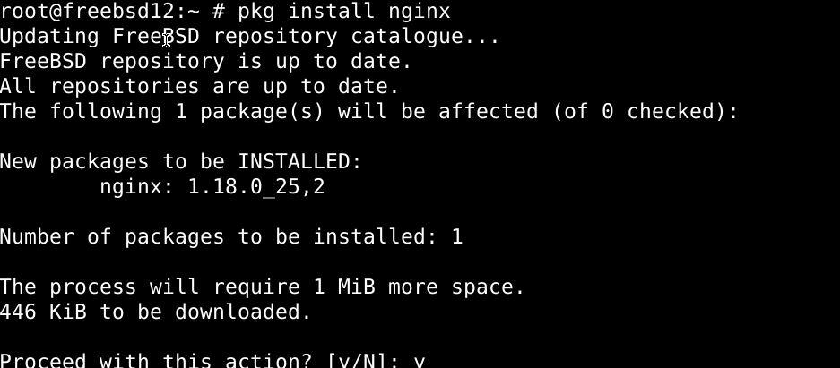
This should install Nginx on your FreeBSD webserver.

Step 3: Enable the Nginx Service on FreeBSD
Type in the command below to enable the Nginx web server
$ echo 'nginx_enable="YES"' >> /etc/rc.conf
Alternatively, you can also type in:
$ sudo sysrc nginx_enable="YES"
That’s about it with the installation.

Getting started with Nginx on FreeBSD
Launch an Nginx server
Launch Nginx by typing the following into the command shell and pressing enter:
$ /usr/local/etc/rc.d/nginx start
Alternatively, you can issue the command below:
$ service nginx start
Close an Nginx Server
To exit an Nginx server, issue the command below:
$ /usr/local/etc/rc.d/nginx stop
You can also type in the more concise command as well:
$ service nginx stop
This command should quit the Nginx server
Rebooting Nginx server
Issue the command below to restart the Nginx server.
$ /usr/local/etc/rc.d/nginx restart
Alternatively,
$ service nginx restart
The Nginx server should restart upon the execution of the command above.
Reloading Nginx webservers post configuration
To restart an Nginx server after editing the configuration file, use the command below:
$ /usr/local/etc/rc.d/nginx reload
You can also use:
$ service nginx reload

Important files in Nginx
- The Default configuration file for Nginx in FreeBSD is located at: /usr/local/etc/nginx/nginx.conf
- The ports on which Nginx listens to by default are 80 & 443
- The file that contains all the error details is /var/log/nginx-error.log
- The file that records the details related to access requests is /var/log/nginx-access.log
- The root document in Nginx is located at the /usr/local/www/nginx/ directory.

Testing the Nginx setup on FreeBSD
Copy and paste the following link into the URL field in your web browser:
http://server-ip-here/

Creating a website with Nginx
Start by setting up a directory by issuing the mkdir command:
$ mkdir /wwwwiki
Then create a new user for your domain with the command below:
$ pw user add -n wwwwiki -c 'Wiki User' -d /nonexistent -s /usr/sbin/nologin
Lock the username with the following command:
$ pw lock wwwwiki
Then chalk up a file to test things out:
$ sudo nano /wwwwiki/index.html
Then copy-paste the following into the file:
# <html>
# <head>
# <title>younis's personal wiki dir</title>
# </head>
# <body>
# <h1>Wiki dir</h1>
# <p>This is a test and I will configure PHP 7.x to host mediawiki</p>
# <hr>
# &copy; <a href="https://www.linuxhint.com/yunissaid12">www.linuxhint.com</a>
# </body>
# </html>
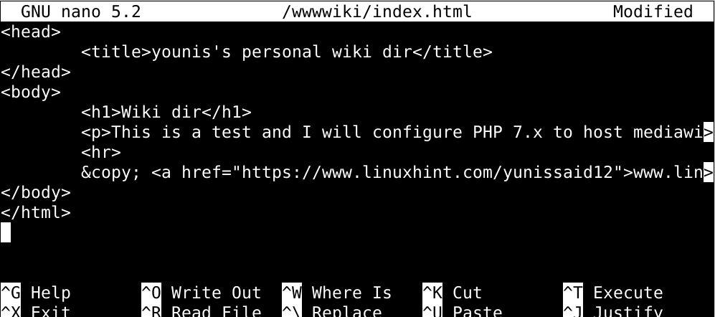
Then allot the group ownership with the commands below:
$ chown -R wwwwiki:wwwwiki /wwwwiki/
$ chmod -R 0555 /wwwwiki/
$ ls -ld /wwwwiki/
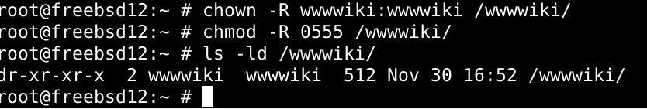

Configure Nginx for wiki virtual domain or IP address
Start by creating a configuration file with the commands below:
$ mkdir /usr/local/etc/nginx/vdomains/
$ sudo nano /usr/local/etc/nginx/vdomains/http.10.0.2.15.conf
Then copy-paste thefollowing text to this file and make appropriate changes to the text below:
# server {
# server_name 10.0.2.15; # virtual IP or domain name here
# access_log /var/log/nginx/10.0.2.15.access.log; # log files
# error_log /var/log/nginx/10.0.2.15.error.log;
# root /wwwwiki; # root dir for this virtual host
# ## add more config below such as PHP and so on ##
#}
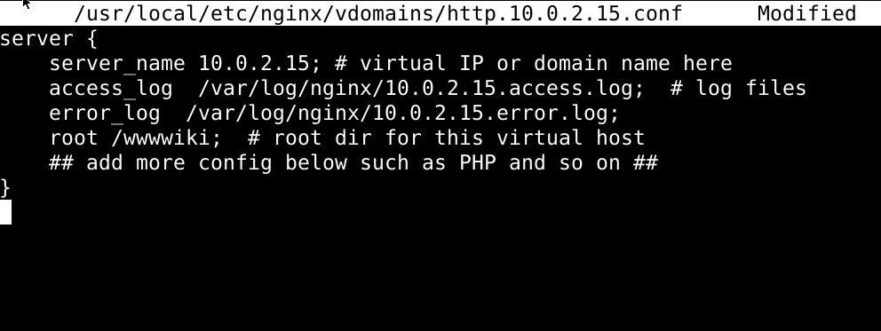
Don’t forget to save the file before you exit it. Then use the command below to update our configuration file:
$ sudo nano /usr/local/etc/nginx/nginx.conf
Then append the following towards the end:
include "vdomains/*.conf";
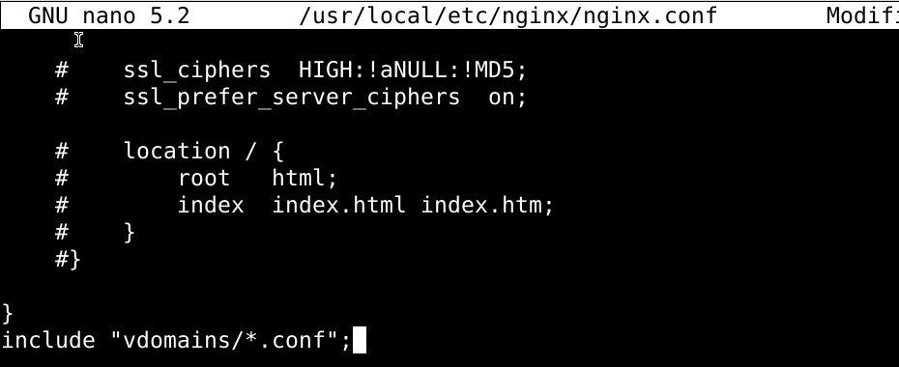
Again, save and exit this file. Then verify nginx using the following command:
$ nginx -t
$ service nginx reload
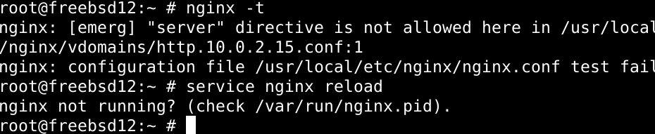
Lastly, test the configuration by issuing your IP address:
http://10.0.2.15/

In summary
That’s about it for today’s tutorial. We explained how to install Nginx on a FreeBSD server using the ports system and the pkg command, and how to enable the Nginx service on FreeBSD. We also saw how to set up a website with Nginx and introduced Nginx to the new users. The instructions here should work out for you just fine.
https://linuxhint.com/installing_nginx_freebsd/

